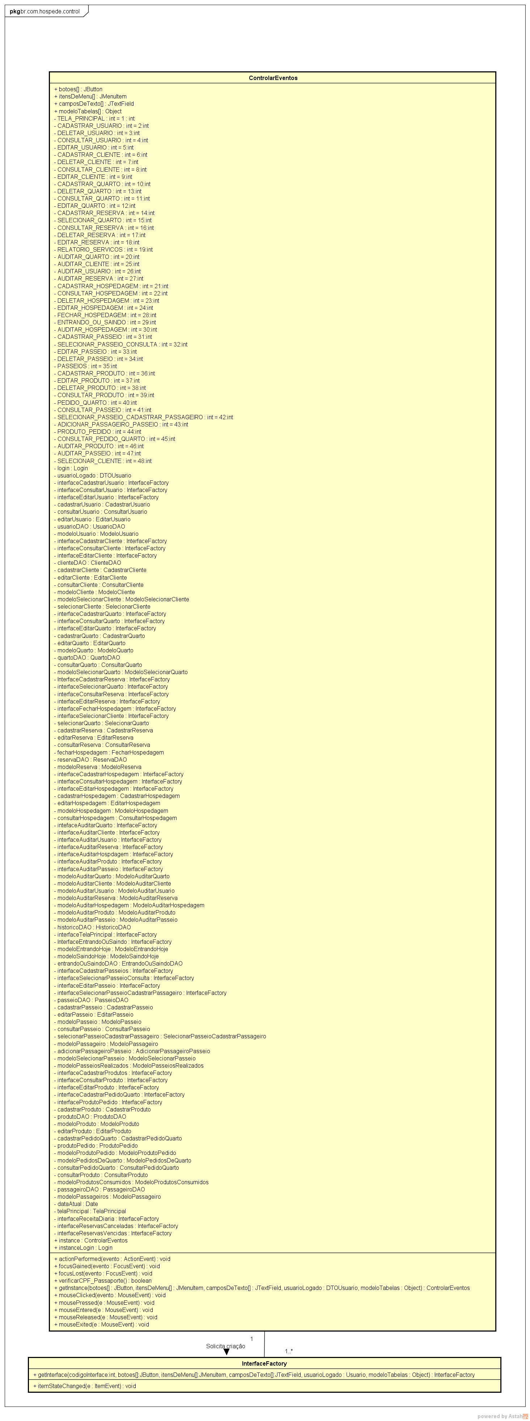

51

**Figura 3** – Diagrama de classes Control Control